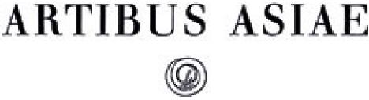

Imported Mirrors in the Minusinsk Basin

Author(s): E. Loubo-Lesnitchenko

Reviewed work(s):

Source: *Artibus Asiae,* Vol. 35, No. 1/2 (1973), pp. 25-61 Published by: Artibus Asiae Publishers

Stable URL: <http://www.jstor.org/stable/3249574>

Accessed: 16/04/2012 09:26

Your use of the JSTOR archive indicates your acceptance of the Terms & Conditions of Use, available at <http://www.jstor.org/page/info/about/policies/terms.jsp>

JSTOR is a not-for-profit service that helps scholars, researchers, and students discover, use, and build upon a wide range of content in a trusted digital archive. We use information technology and tools to increase productivity and facilitate new forms of scholarship. For more information about JSTOR, please contact [support@jstor.org](mailto:support@jstor.org).

|  |  |
| --- | --- |
|  | *Artibus Asiae Publishers* is collaborating with JSTOR to digitize, preserve and extend access to *Artibus Asiae.* |

**E. LOUBO-LESNITCHENKO**

**IMPORTED MIRRORS IN THE MINUSINSK BASIN**

he archeological study of the main centre of Siberian civilization, the Basin of Minusinsk, has revealed a number of very important problems in the history of this area.

T

Suffice it to recall the complex problems in the study of the cultures of Karasuk and Tagar, the problem of the Ting-ling tribe, the written language of the Orkhon and Yenisei, the role of the supremacy of the Kirghis in the political life and culture of Central Asia.

For the study of the Minusinsk basin,' the insufficiency of written sources, local, Far Eastern, or Islamic, is compensated by a very large quantity of archaeological material. This material is dispersed in many museums in the USSR, and in the West, and it is only partially documented, because the great majority of objects from the Minusinsk Basin are chance finds. Consequently a systematic attempt to distinguish the different groups of monuments, should be of value.

Among the chance finds of the South Siberian territory, imported bronze mirrors are fre­quently encountered. The greater part of these mirrors is kept in the museums of Siberia, first of all in the Museum in Minusinsk, but also in the University Museum in Tomsk, and in the museums in Irkutsk, Krasnoyarsk, and Abakan. Collections of imported mirrors exist also in the National Historical Museum in Moscow, in the National Eremitage in Leningrad, and in the Museum in Helsinki, the latter known through publications. Furthermore the Academy of Sciences of the USSR possesses drawings by artists of the first half of the eighteenth century after mirrors in the collection of D. G. Messerschmidt, which are not preserved any more.2

It can be said that the history of the study of the imported mirrors of Southern Siberia is 275 years old, since finds there of imported mirrors are first mentioned in a book by a Dutchman, Nikolaes Witsen, published in 1692. The book gives a picture of such a mirror, found in a tomb near Verkhotur, and an attempt **3** to translate the inscription on it.

Interesting information on finds of Chinese and Iranian mirrors in ancient tombs is found in the work of a captive Swedish officer, Ph. Strahlenberg, who lived in Siberia from 1713-1722, where also4 pictures of three such mirrors are given.

By the historically established concept "Minusinsk Basin" or "Minusinsk territory" is understood the southern part of the territory of Krasnoyarsk.

**2** Concerning these drawings see T.K.Shafranovskaya, Sokrovisca Kunstkamery (Po risunkam khudoznikov XVIII v.), *Soy. etnogr.,* 2965, no.z.

**3** Nicolaes Witsen, *Noord en Oost Tartarye,* Amsterdam, 2692, vol.; p.778. The mirror he published was made the object of a special study by Yang Lien-sheng, who gave a corrected translation of its inscription in "An inscribed Han mirror discovered in Siberia," *T'oung pao,* 2933. In our opinion Witsen's mirror is a izth to 24th century copy of a Han original of the 2nd century A.D.

**4** ph. Strahlenberg, *Das Nord-und-Ostlitbe Theil von Europa and Aden,* Stockholm, 273o, Tab.V—d, IX, XX—b. See also V. Radlov, *Sibirskie drevnosti, I, a,* St. Petersburg, 2892, pp.32-48.

In spite of the great lapse of time since the publication of these books, there has been no special study of these mirrors up to date.

The scanty literature concerning this question, consists in general of works which reproduce such mirrors among other Siberian antiquities, and, at best, try to decipher the inscription, and to date it.s Some information on imported mirrors is found in the general works of S. V. Kiselev6 and L. R. Kyzlasova.7

Nevertheless, the study of this large collection, numbering around 3 5 o pieces, certainly has great significance for the history of civilization. The imported mirrors furnish very valuable material concerning the history of the foreign connections of the local population, during woo years, from the fourth century B. C. to the fourteenth century A. D. Moreover the collection under review contains much that is valuable for the study of problems of production technique, ornamentation and style, reading of inscriptions, understanding of religious beliefs and imagery. Some of the mirrors are unique masterpieces of art.

The attempt to systematize and classify these mirrors met with some difficulties, mainly the absence of accurate dating of many, chiefly, late mirrors, to stablish accurate distinctions be­tween original mirrors of the Han period (third c. B.C.–third c. A.D.) and later copies of these, and the last but not the least important one —the distinction of local copies made from the imported models.

These problems will be dealt with in detail below together with the description of the differ­ent groups. Complex methods have been used in the systematization of the collection: analogies with dated mirrors, and stylistic analysis. About one half of the total number of mirrors (16o pieces) has been subjected to spectral analysis by I. V. Bogdanova-Berezovskaya in the labora­tory for archeological technology. This analysis, made for the first time on such a grand scale, proved to be of considerable help in the work on the mirrors.

Chronologically, the mirrors can be divided into five groups, connected with the principal stages in the history of the Minusinsk Basin.

z. The Tagar period, fourth-third centuries B.C.

1. The Ta5tyk period, second century B.C.—fifth century A.D.
2. The period of the Turkish Khan-ships and the supremacy of the Kirghiz people, sixth cen­tury—middle of tenth century A.D.
3. The pre-Mongol period, middle of tenth century—beginning of the thirteenth century A.D. s. The Mongol and post-Mongol periods, beginning of the thirteenth century—sixteenth century.

Besides these, copies of Han mirrors made in the ninth—sixteenth centuries A.D. were put into a separate group.

**5** R. Martin, *Sibirica, Ein Beitragzur Kenntnis der Vorgescbicbte and Kultur Sibiriscber Volker,* Stockholm, 1897 ; A. M. Tallgren, *La collection Tovostine,* Helsingfors, 1917; also his "Trouvailles isolees sibiriennes prehistoriques au Musee Nationale de Finlande," *Suomen Muistaybdistyksen Aikakauskirja, XXIX,* 3, Helsinki, 1919; Yermolaev, *Isimskaya kollekciya,* Kras­noyarsk, 1914; E.P.Rygdylon, "Kitaiskie znaki i nadpisi na arkhaeologiceskikh predmetakh s Yeniseya," *Epigrafika Vostoke, 1951,* U.

**6 S.** V. Kiselev, *Drevnaya istoriya Yuznoi Siberi,* Moscow, 195 I.

**7** L.R.Kyzlasov, *Tal*kska.ya epokba,* Moscow, 196o.

The proposed classification basically coincides with the traditional grouping of Far Eastern, mainly Chinese, mirrors by dynasties.

An ancient local tradition of mirror making existed in Siberia before the appearance of im­ported mirrors. The local mirrors are usually round discs, slightly convex, with a loop on the back side, sometimes have a border, and are without ornaments.

The local manufacture of mirrors appears in Siberia in the Andronovo period in the middle of the second millennium B.C., and continues on a larger scale during the Karasuk, twelfth—seventh c. B.C.), and the Tagar cultures (seventh—third c. B.C.).8 Until now the question has not been resolved, whether mirrors appeared in China under the influence of South Siberian prototypes, or originated independent of these.

Without going into details let us remark only that in favour of the first proposition speak the following circumstances : The usual type of Chinese mirror, as well as the Siberian, has the shape of a circular disc with a loop on the obverse. Mirrors appeared in Siberia considerably ear­lier than in China. Thus, if the Siberian mirrors go back to the Andronovo period, and by the time of Karasuk are a common phenomenon, we have in China only two finds of mirrors earlier than the Ch'un-ch'iu period (722-481 B.C.) One of these dating from the end of the Shang period (twelfth—eleventh c. B.C.), was discovered at An-yang.9 A few others, believed to date from the eighth century B.C., came from a tomb of the ruler of the state of Kuo.10 The first mention of mirrors in the ancient literature such as the *Shih-ching, Shu-ching,* and the *Tso-chuan,* are also believed to go back to the seventh—sixth centuries B. C.11

The basic shape of the Chinese mirror was that of a round mirror with a loop on the back side throughout the whole period of their existence. An explanation of this fact may be found in the cosmogonic ideas of the ancient Chinese, according to which the mirror was a miniature copy of the universe. And as the universe had a circular shape the mirrors were consequently made round also).

The appearance of imported mirrors coincides with the end of the Tagar period (fourth c. B.C.). By that time important changes in the manufacture of mirrors had taken place. Besides the manufacture of the circular mirrors with a knob on the obverse, the traditional type in Si­beria, new forms appeared: mirrors with a knob on four legs and mirrors with handle on the side, the back of which was sometimes decorated with ornaments.=3

The first group, in our classification also the smallest in numbers, comprises four mirrors. Only one of these is from the Minusinsk Basin proper, the rest were found in adjacent terri‑

**8** M.P. Gryaznov, "Istoria drevnikh plemen Verkhnei Obi," *M. I . A.,* no. 48, 1956, pl.III, no.3 ; and M.N. Komarova, "Tomskii mogilnik-pamyatnik istorii drevnikh plemen lesnei polosy Zapadnoi Sibiri," no. 24, 1956, p.38, fig. 8, 4. Cf. also N. L.Clenova, *Proiskhozeienie i rannaya istoria plemen Tagarskoi Kultury Yuznoi Sibiri,* Moscow, 3967, pp.88-90, which contains a bibliography.

**9** Cheng Te-k'un, *Shang China,* Cambridge, 1961, p.168, fig. 14o.

*10 Shang-ts'un-ling, Kuo Kuo mu ti* ("The Cemetery of the State of Kuo at Shang Ts'un Ling") _h Ift RI a It, Peking,

3959, p.27, pl. XXIII, **12.** Also Kuo Mo-jo, "San-men-hsia ch'u-t'u tung ching erh-san shih" = ri 0E1

*Wen-WU,* 1959, x.

" **B.** Karlgren, "Early Chinese mirror inscriptions", *B. M. F. E. A* no. 6, Stockholm, 3934, pp.I2-4.

**12** Concerning the origins of Chinese mirrors see Umehara S., *O-bei ni okeru Shina ko-kyo*

z #13 fA, Tokyo, 1931, PI). 34-35; also his "Chagoku In shu no ko-ky6" t *Sbirin,* 1959,4;

and Komai, Kazuchika, *Chiigoku ko-kyti no kenkyi j #Rik It! t 42)* Ff 5ta, Tokyo, 1953, p.15.

13 For the classification of Siberian mirrors, see S. Kiselev, *op. cit.,* pp. 327, 131, 156, 168, and p1. XXI; also N. L. Clenova, *op.cit.,* pp. 81-92.

tories: the Altai and the region of Tomsk. With the exception of the well known mirror of Pazyryk, these are chance finds. Two mirrors of this group were subjected to spectral analysis. As the analysis proves, they are significantly different in metal composition from the contem­porary mirrors of Tagar, and later copies.

The results of the analysis are similar to these obtained by N. Barnard in the study of mirrors of the Warring States period (fifth—third c. B. C.).i4 This group is characterized by a white metal, with slight patina, which is well preserved, and by carefully executed ornamentation.

Three pieces in this group belong to the so called "Shan tse tsin" mirrors (fig. 1).1s The dating of mirrors of this type on the basis of stylistic and typological analysis has been carried out by Karlgren and Liang Shang-ch'un. While Liang places them in the quite large frame of the Warring States period,16 B. Karlgren dates them in the fourth century B.C."

In a study of mirrors of this type, existing in archeological collections, Chou Shi-jun dates them in approximately the same period.18 These mirrors, which constitute 3/4 of the total number of the so called "Ch'u" mirrors, were probably made over a fairly long period of time.

Mirrors with the representation of a quatrefoil and comma shapes (fig. 2) are comparatively rare, and according to Chou Shi-jun, are found first in burials from middle of the period of the Warring States.'9 That date basically agrees with B. Karlgren's dating which places the beginning of the appearance of mirrors of this type in the first half of the fourth century B. C.20

All four mirrors in this group belong to the so called Ch'u mirrors, that is mirrors manu­factured in the territory of the ancient state of Ch'u. The finds of Ch'u mirrors in the territory of Southern Siberia confirm the information given by Chang Ch'ien, believed to be of the second century B.C. saying that already before the discovery of the silk road, goods from Shu (the territory of Western Ch'u, located in the Szechuan of our time), reached Central Asia.22

For the history of mirrors in Southern Siberia, the Ta§tyk period (second c. B.C.—fifth c. A. **D.)** is a period of change. In the Tagar period preceding the Tagtyk epoch, we can observe a flourishing of the local production of mirrors, the types of which were linked to cultural in­fluences coming from the West. With the arrival of tribes of Huns, which marks the beginning of the Tagtyk period, we see, however, that the local production of mirrors apparently ceases, and in the following times mirrors occurring in Southern Siberia, are related, with a few excep­tions, to the cultural orbit of the Far East.22

Around the time of Christ a hybrid form of mirrors appears in Siberia. The characteristics of these mirrors are: a raised border, the presence of a rim on the back side, and a rosette with four points around the knob. This hybrid form becomes quickly widespread over the huge

14 N. Barnard, *Bronze Casting and Bronze Alloys in Ancient China,* Tokyo, 1961, p.192, p1.9.

**15** For the symbolism of the ornaments of this type of mirror see Komai, *op. cit., pp.72-76.*

16 See Liang Shang-ch'un, *Yen-k'u-ts'ang chins* ± l 0, Peking, 1940, I, P.7.

**17** B. Karlgren, "Huai and Han", *B.M.F.E.A.,* n0.13, Stockholm, 1941, PP.55-62; also his "Some pre-Han mirrors," *ibid.,* no.35, 1963, pp.161-169.

*Hu-nan ch'u-tu tung thing tre-lu 1411 i =i*a, Peking, 196o, pp.7-8. Also J. Haskins, "The Chinese mirror

from Pazyryk," *Archives of the Chinese Art Society of America, XVIII,* 1964, PP. 57-58.

**19** *Hu-nan ch'u-eu,* **p.7.**

**20** Karlgren, "Huai and Han", pp.55-62.

**21** I.A.Bicurin ("Father Iakinf"), *Sobranie svedanii o narodakh, obitaysikb v Srednei Asii v drevnie vremena, Vol.II*, Moscow-Leningrad, 195o, pp.'s 3-154.

**22** L. R. Kiselev, *op. cit.,* pp. 85-86.

territory of the Sarmatian world up to Germany and France,23 beginning in the first century A.D. In the formation of this type the Minusinsk Basin probably played a prominent part. These events took place in the wake of great changes occurring in Southern Siberia. The expan­sion of cultural and commercial relations of the local population coincides with the powerful wave of the newly arrived bearers of the Tagtyk culture.

To this second group, in our classification, belong twelve mirrors. The larger part, eight pieces, are Han mirrors. Only two pieces were excavated, the rest are chance finds.

One of the most intricate problems in the study of the mirrors was that of extricating the original mirrors of the Han period from the mass of later copies. In this the analysis of the metal played the most important role. In the China of Han times great significance was attached to the purity of the metal used in the making of mirrors. The necessity of careful manufacture was stipulated by the magical and ritual purpose, which frequently found expression in the inscrip­tions on the mirrors. For this reason original Han mirrors are made of a characteristic white metal, only slightly covered with a dark patina, and have a carefully executed ornamentation. Furthermore, the central knob-loop on Han mirrors always has a round shape different from the knobs with a cut off top found on the later copies.

Almost all Han mirrors, with the exception of one preserved whole, are preserved in frag­ments whose edges are worn smooth, a fact indicating that they were in use over a long period of time and highly valued by the local population.

The dating of Han mirrors has been worked out quite accurately thanks to the work of Liang Shang-ch'un,24 B. Karlgren,35 A. Bulling26 and to the many datable finds of recent years.27

As the earliest mirror in our second group we have to consider a fragment, datable to the second c. B.C. Its ornament is characteristic of one of the early phases of stylization of the main motif in the ornament of Han times, the cloud scroll. A mirror with an inscription (fig. 3) dates from the second half of Western Han (first c. B.C.). Two mirrors belonging in to the so called TLV category (fig. 4), frequently encountered among Han mirrors, date from the end of Western Han, or the beginning of Eastern Han (first c. A. D.).28 Three fragments can be dated into the period of Eastern Han (first—third c. A. D.). Two of these belonging into the beginning of that period show the last stage in the development of the cloud scroll. In the end of the Han period we have to date a fragment on which the ornament shows the gradual stylization of the repre­sentation of animals in the outer zone of the ornamentation.

The question of local casts of mirrors of the Tagtyk period in the Minusinsk Basin is still not elucidated to date, since not a single mirror of that kind has been discovered in a documented find. However we seriously doubt that the Tagtyks used only the not very numerous imported mirrors, which they certainly valued very highly. It seems possible that a mirror with a scroll ornament, preserved in the Eremitage (fig. 5 o) can be dated into the Tagtyk period. A reason for this dating is the metal composition, which is close to that of Han mirrors and noticeably

**23** A.M.Khazanov, "Genesis Sarmatskikh bronzovykh zerkal", *Sov. Arkh.,* 1963, no.4, pp.67-69.

**24** Liang Shang-ch'un, *op. cit.,* **vol. 2** a, b, v.

**25** Karlgren's classification system in "Huai and Han" extends to the end of Western Han (end 1st cent. B.C.).

26 A. Bulling, *The Decoration of Mirrors of the Han Period,* Ascona, 1961.

27 See especially *Lo-yang ch'u-tu ku thing* geHi±ta, Peking, 1961.

**28** The origin and semantics of the ornaments of these mirrors have been repeatedly discussed. See S.Cammann, "The TLV pattern on Chinese mirrors of the Han period", *Jour. Am. Or. Soc.,* vol.68, Oct.—Dec.1948.

different from that of later copies. It differs also from later copies in that it is massive and has a round knobloop in the centre.

The end of the Ta§tyk period, which is related to the great migration of nations, is one of the darkest periods in the history of the Minusinsk Basin which in this period falls under the influence of tribal alliances, following each other in kaleidoscopic changes, such as that of the Hsien-pi, the T'o-pa, and the Juan-juan. In this period we can date three mirrors. They are round, have a knob-loop in the centre, and their ornament indicates Western, probably Sarma­tian origin (fig. 5). These finds support the fact that during the time of the tribal unions of the third to the fifth centuries, the ties of the Minusinsk Basin with the Far East weakened, and instead the connections to the West became stronger.

The next group of mirrors which can be dated in the time of the Turkish Khan ships and the supremacy of the Kirghiz people (sixth c.—middle of the tenth c. A. D.), includes 83 pieces. During this period significant developments took place in the life of the peoples of Central Asia and Southern Siberia. In order to consider the mirrors in the light of these developments, a very detailed classification is important. We have based our work, in the main, on the dating of Liang Shang-ch'un,29 S. Umehara 30 and B. Gyllensvard.3' On the basis of their classifications some categories of mirrors can be dated quite precisely, while others cannot be dated closely at present.

The earliest mirrors of this group can be dated in the end of the sixth to the beginning of the seventh centuries A. D. These are mirrors with representations of four deities, and the twelve signs of the zodiac (fig. 6). Similar mirrors were widely diffused in the Far East and are known in numerous similar examples.

The cycle of the twelve animals of the zodiac was widely known among the Turkish people, as well as among the Kirghiz. This is attested by the "T'ang shu", where it is said : "They count the years by means of the twelve animals; for example if the year is governed by the cyclical sign "Tzu", they call it the year of the mouse; if it is under the sign "Sui", they call it the year of the dog. This is so (among the Kirghiz) equally among the Hui-hu(s)."32 The similarity of the cycles was the basis for Chavannes' assumption that the idea of a cycle taking place itself was taken over by the Chinese from the Turkish peoples.33 Therefore it is completely plausible to suppose that the symbolism of this kind of mirror was also familiar and intelligible to the ancient Kirghiz.

Close to the type examined above is a mirror with a representation of the Pa kua, twelve animals of the zodiac and an inscription executed in an archaic manner (fig. 7). This mirror is quite difficult to date, but apparently must be placed in the beginning of the T'ang period.

The inscription on the edge of the mirror is of great interest; it is executed in an archaic kind of characters. This inscription is strongly imbued with Taoist symbolism and still connected with the inscriptions of the Han period. It is noteworthy that technically the mirror is very care­fully made.

**29** Liang, *op.cit.,* vol.3.

**3°** Umehara, *Tokyo taikan* ) t Kyoto, 1937.

31 B. Gyllensvard, *T'ang Gold and Silver,* Stockholm, 1957.

32 N. V. Kyuner, *Kitaiskie isvestiya o narodakh Yuznoi Sibiri, Centralnoi Azii i Dalnego Vostoka,* Moscow, 1961, p.58.

33 E.Chavannes, "Le cycle turque des douze animaux", *T'ounq pao,* V,1906; also L. de Saussure, "Le cycle des douze ani­maux et le symbolisme cosmologique", *Journal asiatique,* 1920,

To the category of the Pa kua mirrors must also be related a square mirror with an inscrip­tion executed in clear cut, regular writing (fig. 8). According to the beliefs of the ancient Taoists such mirrors were connected with the moon and intended for the collecting of lunar dew.34 The simplicity and grace of the decor together with the magnificent quality of the metal make this mirror an outstanding monument of the art of the T'ang period. It is interesting to note that two runical signs are scratched into this mirror, probably the mark of a ruler.

The typical mirrors of the T'ang period with the representation of animals and a grape vine were widely diffused in the Minusinsk Basin. Suffice it to say that together with the local casts, they number 25 pieces (fig. 9-- 1). The dating and the elucidation of the symbolism of the decoration on the mirrors of this type is one of the most complex problems in the history of the study of Sui and T'ang mirrors. In the process of the study of them the scholars had to overcome an old tradition, going back to Sung times, that this type of mirror dated from the Han period. Thanks to the efforts of S. Cammann35 and a number of other scholars, the dating and the symbolism of this numerically large category of mirrors have become much clearer today.

The mirrors with animals and grapevine conserve the old scheme of the Han period, dividing the decorated area into concentric zones with the knob-loop in the centre. But the elements on which the decor is based, the lions and the vines of the grapevine make their appearance in Chinese art only in pre-T'ang times, coming from the West. During the period of their manu­facture these mirrors with representations of animals and grapevines undergo a transformation and become filled with the traditional Chinese symbols.

As the apparently oldest one of this mirrors of this type we have to consider a mirror in the museum in Irkutsk which is only preserved in a drawing. The representation of four swiftly running lions preserves the symbolism of the ancient gods, the *ssti-.Then,* representing the idea of the four sides of the world.

The grapevine scrolls of the outer zone have clear repeated curves and are not overloaded with details. This mirror must date from the Sui period or the beginning of T'ang.

The decoration of the majority of the mirrors of this type, found in the Minusinsk Basin, represents six lions in various poses around a knob in form of a lion, among the branches of the vine. The lions are usually placed in strictly symmetrical fashion and put inside a scroll of the grapevine. In the outer zone we find representations of birds (usually orioles) also surrounded by scrolls. The six lions on the mirror symbolize the *liu-ho,* "the six directions" (the four compass quarters, zenith and nadir). Mirrors with six lions have to be dated in the flourishing period of T'ang (end of the seventh-eighth century). Probably in the same period we have to date a mirror with five lions, in the Eremitage. The variant with five lions symbolizes the *wu hying,* the five elements which played an important role in the ancient Chinese cosmogony.

Towards the end of the T'ang period occurs the decomposition of the old schema of ordering the decoration. The ornament becomes overloaded with detail, winged animals appear together with the lions, as well as paired birds, which brings them close to the so called wedding mirrors. From this period date two mirrors. One of these is unique. It differs from the other mirrors in the

34 P. Pelliot "Bulletin critique sur Lo Tchen-yu, Kou King t'ou lou et Tomioka Kenzo, Kokei no kenkyu", *T'oung pao,* 1921, pp.151-152.

35 S.Cammann, "The lion and grape pattern on Chinese bronze mirrors", *Artibus Asiae, XVI,* 3953.

especially carefull execution of the ornament and in the large dimension, a diameter of 22 cm, which is twice as large as the usual mirror of this type.

The mirrors with representations of animals and grapevines were particularly popular among the Kirghiz. This is proven by the existence of a great quantity of locally cast copies. The orna­ment of these becomes more and more conventionalized as a result of the endless repetition over a period of time and finally winds up changing into a simplified schema, the original meaning of which can only be guessed at by way of a whole row of comparisons.

Quite close to the mirrors with representations of animals and grapevines is a group which shows in the central zone a decor of four lions running through scrolls. The outer zone is oc­cupied by stylized growing vine scrolls. Although closely related by their subject to the previous group, these mirrors have much in common in their composition with the widely diffused group of T'ang mirrors with four running animals. The type of lions as well as the small broken up design of the border ornament indicate that this group must be dated in the second half of T'ang (eighth-ninth c.).

Like the mirrors of the previous group these mirrors also were copied by the Kirghiz in­numerable times, as is attested by the locally cast copies. On these the details of the ornament disappeared almost completely as the result of the frequent copying. The last stage is represented by two pieces, on which the outer zone of the ornament has disappeared, and the running lions have been transformed into formless comma shapes (fig. z 1).

Two examples prove to be copies of mirrors where added running animals are introduced in the outer zone of the ornament. The same lions are found, in even more conventionalized form, on a mirror with an inscription mentioning Ts'in wang. The inscription runs along the edge of the mirror. This inscription is of one of the most widely diffused types of inscriptions in T'ang times, consisting of four groups of five words. Similar inscriptions are also found in Post­T'ang times as is attested by the find of a mirror in a burial of the Sung period.36

Related to the mirrors examined above, by their composition are mirrors with a decor divided into two zones. These show flying orioles among flowers and butterflys.

One of the important innovations in the ornamentation of the mirrors in the middle of the T'ang period was to abolish the division of the decoration into an inner and an outer zone, with the result that the ornament can freely fill the whole surface. A mirror with the representation of flying birds and butterflies can serve as a striking example (fig. z). It is a very beautiful piece: the particular features of birds in flight are captured with sparing detail on a granulated ground. The symbolism represented on this mirror is widely diffused in the Far East, where the goose is a bird symbolizing the Yang, the active principle in Nature. According to popular belief they always fly in pairs and never take a second wife and for this reason they symbolize faithfulness in marriage.37 Therefore this mirror must be seen as related to the so called wedding mirrors which were widespread in T'ang times, the ornament of which usually shows pairs of birds, as a symbol of a happy marital union.

An interesting specimen of a wedding mirror is a mirror showing two pairs of birds which are facing each other (fig. i 5). This method of symmetrical confrontation is also characteristic of

**36** *Stn-ch'uan Wu-en tuns thing al J(1 ±* Peking, 196o, no.47.

37 C. Williams, *Encyclopedia of Chinese Symbolism and Art Motives,* New York, 196o, pp.214-125.

the wedding mirrors. The mirror shows two geese standing on a flower with opened wings and ribbons in their beaks, and two geese in flight also having ribbons in their beaks.

The birds are executed in the free style characteristic of the T'ang period. The detail of the ribbons in the beaks of the birds are found on many wedding mirrors of the T'ang period. Ap­pearing as a motive borrowed from the Sasanian art of Iran,38 it is soon overgrown by Chinese symbolism. The socalled ribbons—thou—become thanks to their accidental phonetic similarity related by association with thou—longevity, while the knot in the ribbon symbolizes the ever­lasting union between husband and wife.39 Thus the mirror shows a scale of auspicious associa­tions related to marriage. Like the previous one this mirror also is the only one of its kind.

A magnificent specimen of a T'ang mirror found by D. G. Messerschmidt, is preserved in a drawing of the beginning of the i8th century (fig. i 3). On this mirror we see besides the well known graceful phoenix with a ribbon in its beak a fantastic horned and winged animal. The scalloped shape of the mirror and the rosette in form of a lotus are innovations of the middle of the T'ang period.40

A unique mirror of the T'ang period is a large eight-lobed piece (fig. 14) with a decor of two standing phoenixes facing each other. The characters f c "thousand autumns" are placed in cartouches above flowers between the phoenixes. On the border we see flying geese carrying bunches of grapes in their beaks, orioles and designs looking like squares with pendants. On the whole the decor is quiet and well balanced.

The expression "thousand autumns", the wish for longevity, carries still Taoist religious symbolism like an amulet or a charm+. The auspicious symbolism is reinforced by the bunches of grapes in the beaks of the geese, a symbol of fertility, and the diamond shapes, symbols of wealth. This mirror was made especially for the Emperor Hsuan-tsung's birthday. In 729 it was proclaimed as Ch'in ch'iu tse—One Thousand Autumn Festival. This Festival existed

till 74 3 .41 a

Closely related to the wedding mirrors in their symbolism are the so called *hua-niao* mirrors with representations of flowers and birds. Three mirrors in our collection belong into this cate­gory. The decorated area of one is filled with stylized representations of birds and flowers (fig. 16). The decor, executed in low relief, covers almost the whole available space. The mirror is very decorative. The ornaments of the other two are quite similar to each other: Among flowering branches we see alternating pairs of mandarin ducks, a well known symbol of mar­riage, and orioles. The petalled shape of these mirrors, similar to the lobed mirrors, is also an innovation of the second half of the T'ang period. One of these mirrors is apparently a local copy.

An important place among Chinese mirrors of the second half of the T'ang period belongs to those with representations of subject matter taken from myths and legends. A mirror with an illustration of the legend of Confucius meeting the hermit Jung Ch'i-ch'i (fig. 17) is an example of this kind. The rigid symmetry or the circular arrangement of the ornaments, which we have seen in the earlier mirrors, is abandoned in the composition of the decor, and the figures are

**38** Gyllensvard, *op.cit.,* p. I 16.

**39** Liang Shang-ch'un, *op. cit.,* vol. 3, pp. r2—r 3.

40 Gyllensvard, *op. cit.,* p. 89-9o.

41 Ts'ui Hao, *T'ung-supien* fNafg a, Peking, 1958, p.202.

41• T.Akiyama and others, *Arts of China, Vol.I: From Neolithic to the T'ang Period,* Tokyo, 197o, pp.65, 66, 220.

placed freely in the field. For the wider diffusion of mirrors with the representation of the meet­ing between Confucius and Jung Ch'i-ch'i in the Minusinsk Basin speaks the fact that we know three examples of this kind. One is particularly interesting because it bears a scratched-in inscrip­tion of runic signs: "Man Ankhoeteshik a bit of my mirror."42

One of the leading tendencies of Chinese ornamental art of the T'ang period is the great expansion of floral designs. A reflection of this can be seen in a large group of mirrors, most of them preserved only in fragments, with a decor of either realistically executed, or stylized flowers (fig. **20----2 2).** Some of these mirrors are very rare, and a few have no match, to our knowledge.

A fragment published by Strahlenberg is connected with Buddhist subject matter.43 It shows the sacred svastika and the character "Great"; scratched into the edge of the mirror is the runic inscription: "the mirror of Kend Aruk Beg" (fig. 26).

Among the pieces without ornamentation a square mirror with rounded corners is the most interesting one. An inscription, scratched into the edge, mentions a Count Kaifeng

(fig. **27).44**

Thus, the third group in our classification proves that as a result of a great influx of mirrors into the Minusinsk Basin this region constitutes an important area of finds of T'ang mirrors beyond the borders of the Chinese empire. In their significance for cultural history these are in a way analogous to the finds of Sasanian silverware, little known in Iran, that have been dis­covered on Russian territory far away from the Persian borders.

Thus the collection offers very valuable material to the study of T'ang mirrors. It contains all the basic types of that period, and in addition some met with for the first time.

The mirrors are important documents for the foreign relations of the Kirghiz, and show clearly the various phases of the interrelations of the Kirghiz people with the T'ang empire. According to the written sources, the relations of the Kirghiz with the Chinese empire can be divided into three periods, beginning with the year 63 2. After the emperor T'ai-tsung had dis­patched the ambassador Wang I-hung to the Kirghiz they were in close contact for more than a hundred years. Suffice it to say, that the written sources mention for that period eleven Kir­ghiz embassies.45 After the foundation of the empire of the Uighurs which drove the Kirghiz towards the West after the battles of 75 8-75 9 A.D., the contact between the Kirghiz and the T'ang empire weakened and during the following century almost ceased.

After persistent fighting, the Kirghiz destroyed the state of the Uighurs in 839 A.D., and during the next 8o years the empire of the Kirghiz became the supreme power in Central Asia and renewed its contacts with the weakening T'ang regime.

Corresponding to these phases we can single out a group of Sui and early T'ang mirrors in the collection.

Similarly an important number of mirrors belongs to the period of the Kirghiz supremacy (as V. V. Bartold calls it). This group tells us of the wealth and power of the Kirghiz nobility who came into the possession of important art treasures from the neighbouring cultures.

The mirrors, which had come a long way to the Minusinsk Basin, were highly valued by the

**42** *Altturkische Inschriften der Mongolei.* Dritte Lieferung, 1895, p.346. For Jung see H. Giles, *Biog. Dia.,* no.930.

**43** Strahlenberg, *op. cit.,* p1. IX.

**44** Martin, *op. cit.,* p.25.

**45 G.** P. Suprunenko, Dokumenty ob otnoseniyakh Kitaya s Yeniseiskimi Kyrgyzami v istocnike IX veka 'Li Wang-chung hoichan ipin tsi', *Isvestiya AN Kirgizskoi SSR,* seriya obscestvennykh nayk, vol. V, no.1, Frunze, 1963, pp.67-81.

|  |  |
| --- | --- |
|  |  |
| Fig. 2 Mirror showing a quatrefoil and comma shapes Diam. 7,9 cm. 4th c. B.C. Found at Yekaterinovka, Prov. of Tomsk, *National Eremitage, Leningrad* |
| Fig. i Two fragments of a mirror showing a quatrefoil and T shaped figures. 4th. c. B.C. Found in Vostoenoe, *Minusinsk, Museum* |

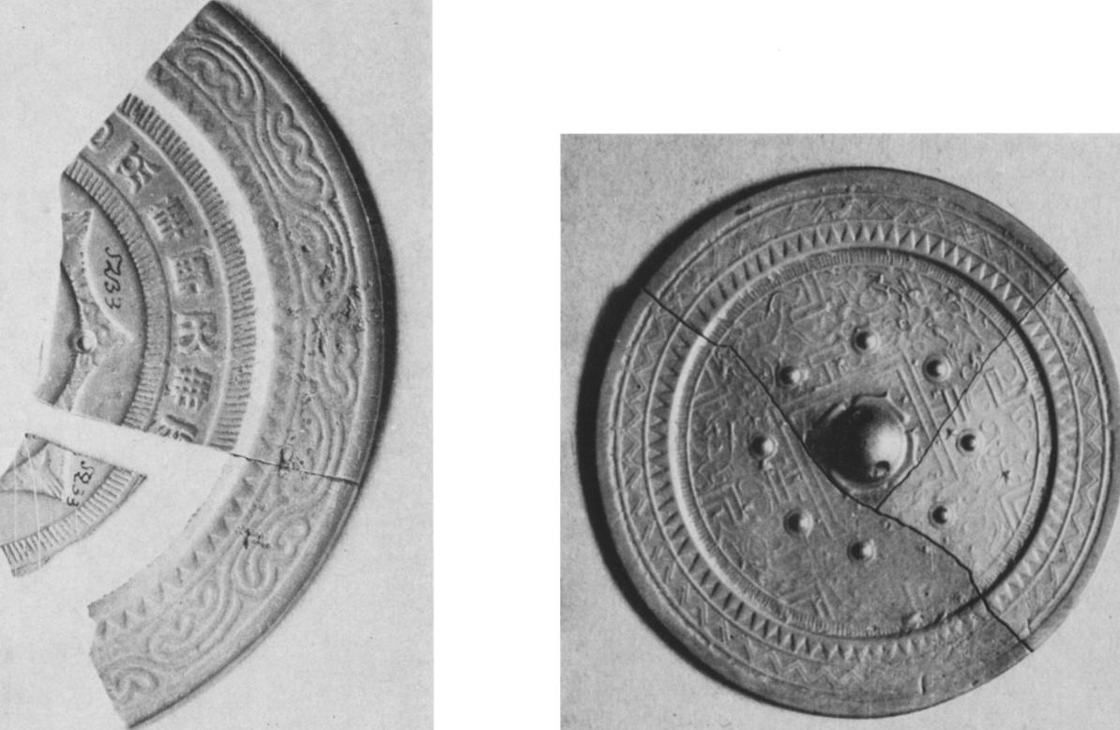

Fig. 3 Mirror with inscription and patterned border. Fig. 4 TLV mirror, D. 14,8 cm. 1st c. A. D. Found at Isim,

Diam. 8,3 cm. 1st. c. B.C.Found at Beiskoe, *Minusinsk, Museum Krasnoyarsk, Museum*

Fig. 5 Mirror with geometrical ornament, Diam. 8,8 cm,  
3rd-5th c. A.D. Found in the Minusinsk and Yenisei area,  
*Minusinsk, Museum*

|  |  |
| --- | --- |
|  |  |
| Fig. 6 Fragment of a mirror showing the zoomorphic signs of the zodiac. 6th-7th c. A.D. Found at Beiskoe, *Minusinsk, Museum* |

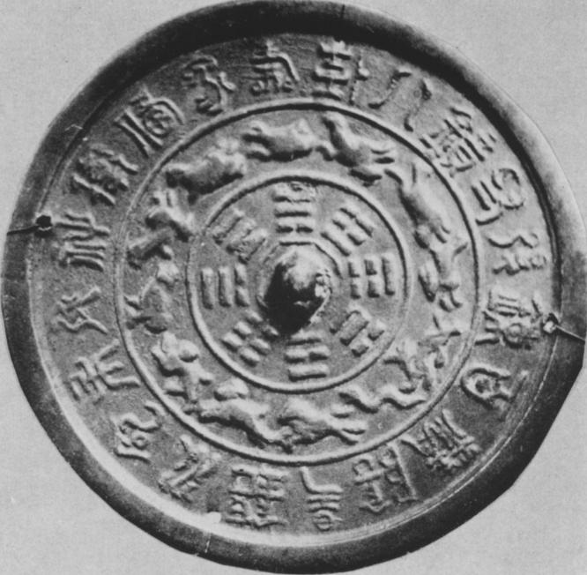

Fig. 7 Mirror showing the Pa Kua and animals of the zodiac,  
Diam. zi cm, 7th-8th c. A.D. Found in Minusinsk Basin,  
*Krasnoyarsk, Museum*

|  |  |  |
| --- | --- | --- |
|  | | Fig. 8  Square mirror showing the Pa kua and inscription, 7th-8th c. A.D.  Found in Minusinsk Basin, *Minusinsk, Museum* |
| Fig. 9  Mirror showing animals and grapevine, 7th-8th c. A.D., Diam. 10,3 cm. Found at Yekaterinovka, Prov. of Tomsk, *National Eremitage, Leningrad* |  | |

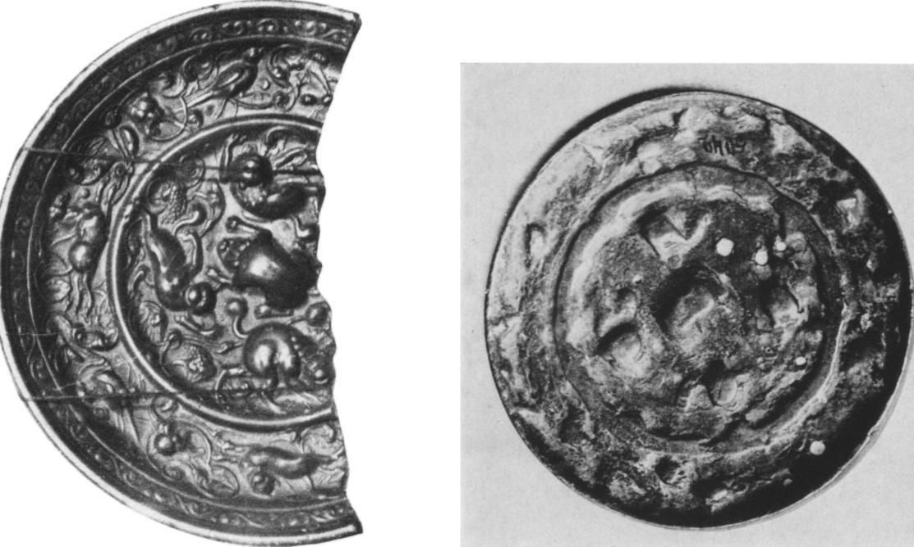

Fig. 10 Mirror showing animals and grapevine, Fig. II Mirror showing animals and grapevine,

detail, Diam. 12 cm. Found in Basin of Minusinsk, local copy, Diam. 9 cm. Found at Beiskoe,

*National Historical Museum, Moscow Minusinsk, Museum*

4

Fig. 12 Mirror showing geese and butterflies, Fig. 15 Mirror showing geese and parrots,

Diam. 10,5 cm. 8th-9th c. A.D. Found at Idrinskoe, Diam. 10,5 cm. 8th-9th c. A.D. Found in Minusinsk Basin,

*Minusinsk, Museum Minusinsk, Museum*

|  |  |
| --- | --- |
|  | Fig. 13  Fragment of a mirror showing a phoenix and a *ch'i-lin.* Drawing of  the first half of the 1 8th c. after original of 8th-9th c. A.D. Found in Minusinsk Basin, *Messerschmidt Collection* |

Fig. 14

Mirror showing two phoenixes, Diam. 22,8 cm. 8th-9th c. A.D.

Found at Sayanskaya, *Minusinsk, Museum*

|  |  |  |
| --- | --- | --- |
|  | | Fig. i6  Mirror showing birds and flowers, Diam. 19,2 cm. 8th-9th c. A.D.  Found at Sukhaya Tes. *Krasnoyarsk, Museum* |
| Fig. 18  Mirror showing ornament of flowers, Diam. 16,z cm. 8th-9th c. A.D.  Found at Sukhaya Tes, *Krasnoyarsk, Museum* |  | |

Fig. 19 Mirror showing lotus leaves, Diam. 6, z cm. Fig. zo Fragment of a mirror showing a flower 9th. c. A.D.

loth c. A.D. Found at Malaya Inya. *Minusznsk, Museum* Found in Minusinsk Basin, *Minusinsk, Museum*

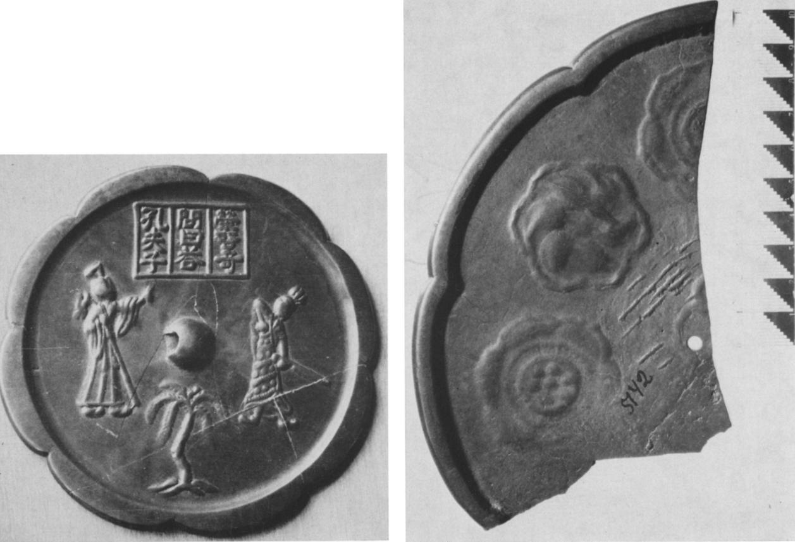

Fig. 17 Mirror showing Confucius and Jung Ch'i-ch Fig. **2**1 Fragment of a mirror showing stylized flowers,

Diam. '2,7 cm. 9th c. A.D. Found at Son. *Abakan, Museum* Found at Bellyk. *Minusinsk Museum*

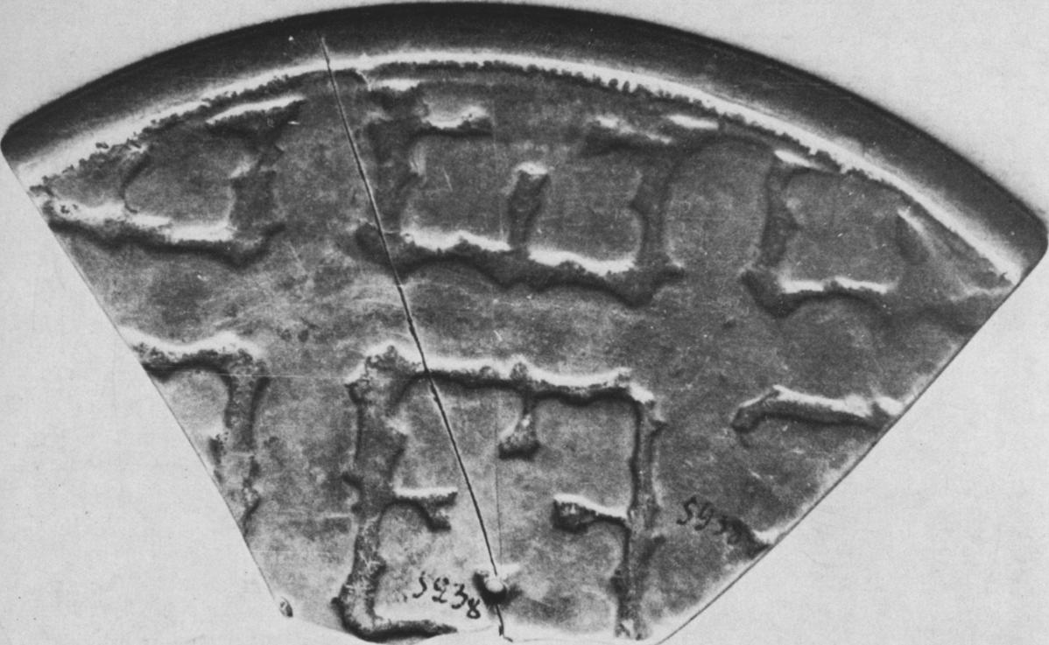

Fig. 22 Fragment of a mirror showing a lotus flower, 8th-9th c. A.D. Found in Minusinsk Basin, *Minusinsk, Museum*

|  |  |
| --- | --- |
|  |  |
| Fig. 23 Fragment of a mirror showing a flying goose, 8th-9th c. A.D. Found at Monok, *Minusinsk, Museum*  Fig. 25 Fragment of a mirror showing a tortoise, 8th-9th c. A.D. Found at Kolmakovo, *Minusinsk, Museum* |

|  |  |
| --- | --- |
|  |  |
| Fig. 26 Fragment of a mirror showing a svastika. 8th-9th c. A. D. with characters and scratched in runic inscription 8th-9th c. A.D. Found in county of Abakan, *Messerschmidt collection* |
| Fig. 24 Fragment of a mirror showing a mandarin duck, 8th-9th c. A.D. Found at in Minusinsk Basin, *Minusinsk, Museum* |

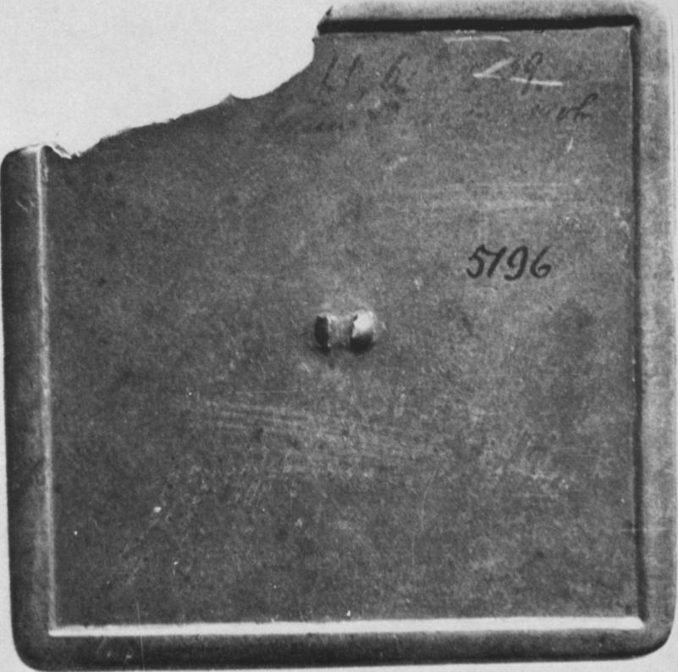

Fig. 27 Square mirror without ornament 13.3 cm. across. 9th—i oth c. A. D.  
Found at Samodurovka, *Minusinsk, Museum*

|  |  |
| --- | --- |
|  | Fig. 28  Mirror showing stylized flowers Diam. i 3 cm. i ith—r zth c. A. D., Found at Beloyarskoe, *Minusinsk, Museum* |

|  |  |
| --- | --- |
| Fig. 29  Mirror showing dragons.  Diam. 12 cm. 11-13 th c. A. D. Found at Dubenskoe.  *Krasnoyarsk, Museum* |  |

Fig. 3o Mirror showing two carps, Diam. 8,5 cm. iith—i3th c. A.D. Fig. 31 Mirror showing a boy and flowers, Diam. 14 cm.

Found at SoSino, *Minusinsk, Museum* i ith—i 3th c. A.D. Found in Minusinsk Basin, *Irkutsk, Museum*

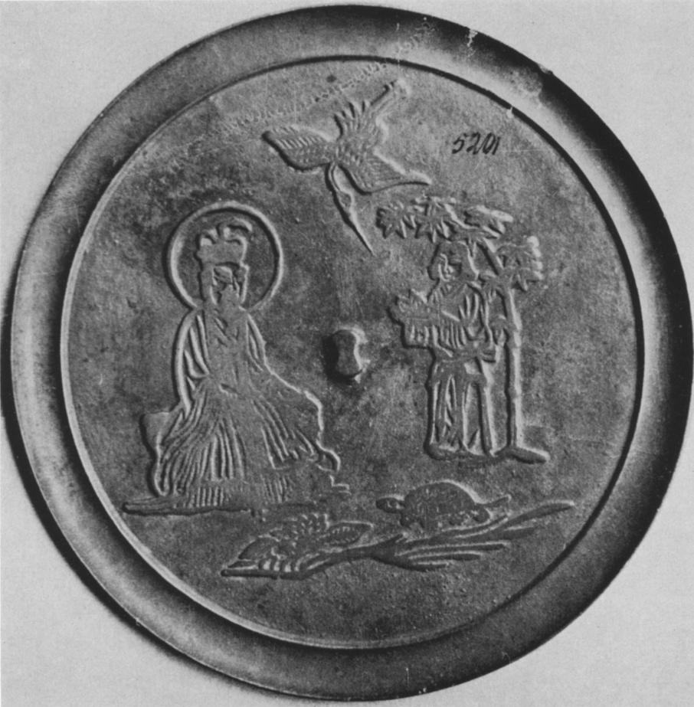

Fig. 32 Mirror showing the Deity of the Great Bear, Diam. 20 cm.  
II-12th c. A.D. Found at Verkhnii Kukbar, *Minusinsk, Museum*

|  |  |
| --- | --- |
|  | Fig. 33  Mirror showing the legendary hermits Ch'ao Fu and Hsu Yu  Diam. 54,5 cm. zth-14th c. A. D.  Found at SuSery, Tomsk, *University Museum* |

Fig. 34

Mirror showing a landscape and a woman, handle broken off, Diam. 9 cm. i ith—i3th c. A.D. Found at Beiskoe,

*National Eremitage, Leningrad*

|  |  |
| --- | --- |
|  | Fig. 35  Mirror showing "the Chinese Rip van Winkle", Wang Chih W, Diam. 11,5 cm. tith—t3th c.A.D. Found at Suknskoe,  *Minusinsk, Museum* |

Fig. 36

Mirror showing lions and inscription, Diam. 9,9 cm. izth—i3th c. A. D.

Found at Tesinskoe.

*Minusinsk, Museum*

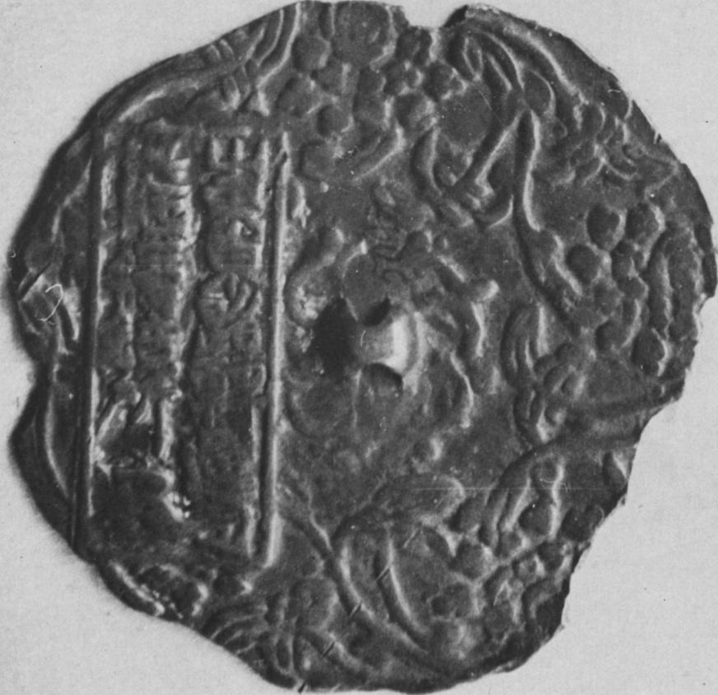

Fig. 37 Mirror showing ornament of flowers and inscription, edges broken off. i ith—i ath c. A. D.  
Found at Sayanskaya. *Minusinsk, Museum*

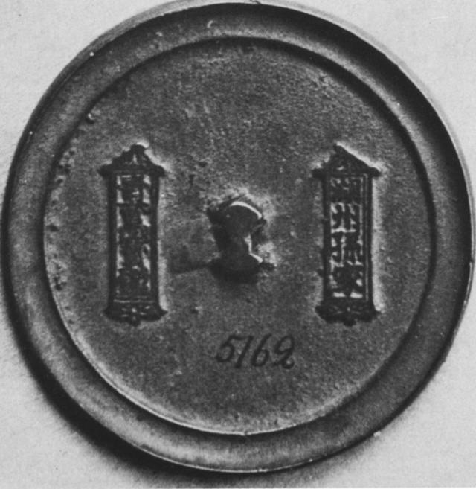

Fig. 38 Mirror with inscription, Diam. 8 cm. izth-13th c. A. D.  
Found in Minusinsk Basin, *Minusinsk Museum*

|  |  |
| --- | --- |
|  |  |
| Fig. 39 Mirror showing fish and crabs. Drawing of the 174os after original of the iith—t zth c. Found in Minusinsk Basin, *Messerschmidt collection* |

Fig. 4o Mirror showing birds and a landscape, Diam. in cm. ith—t zth c. A. D. Found at Bogoi Khabyk., *Minusinsk, Museum*

Fig. 41 Mirror with ornament of arches, Diam. 8,7 cm. Fig. 42 Mirror with ornament of flowers. Diam. 10,5 cm.

roth—t4th c. A. D. Found at Kapterevo, *Minusinsk, Museum* r3th—r4th c. A. D. Found at Bellyk, *Minusinsk, Museum*

|  |  |
| --- | --- |
|  | Fig. 43  Mirror showing two dragons, Diam. tz cm. r3th—t4th c. A.D. Found at Bellyk,  *Minusinsk, Museum* |

Fig. 44

Mirror showing lotus and Buddhist symbols,

izth—i 4th c. A.D. Found at Detkovo, *Minusinsk, Museum*

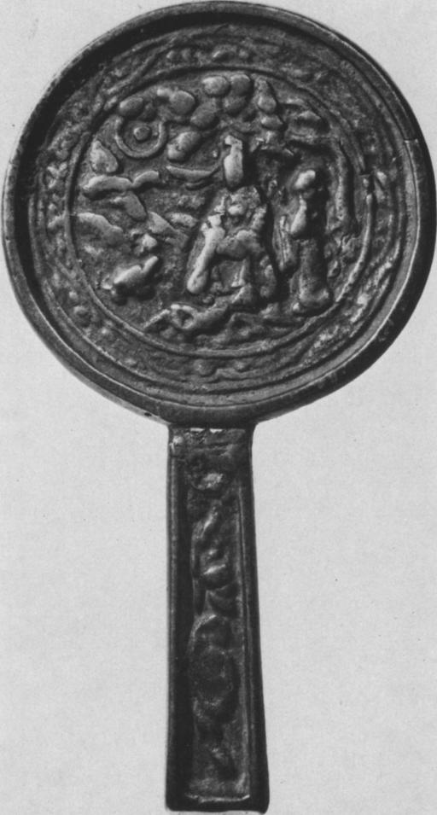

Fig. 46 Mirror showing the Deity of the Great Bear,  
Diam. 9,3 cm. i3th-14th c.A.D. Found in Minusinsk Basin.  
*National Eremitage, Leningrad*

|  |  |
| --- | --- |
|  |  |
| Fig. 45 Mirror showing a scene, Diam. 9,6 cm. i3th—T4th c. A.D. Found at VostoCnoe, *Minusinsk Museum* |

Fig. 47 Mirror showing a rider, Diam. to cm. i ith—i3th c.A.D.  
Found at Starye Knysi, *Minusinsk, Museum*

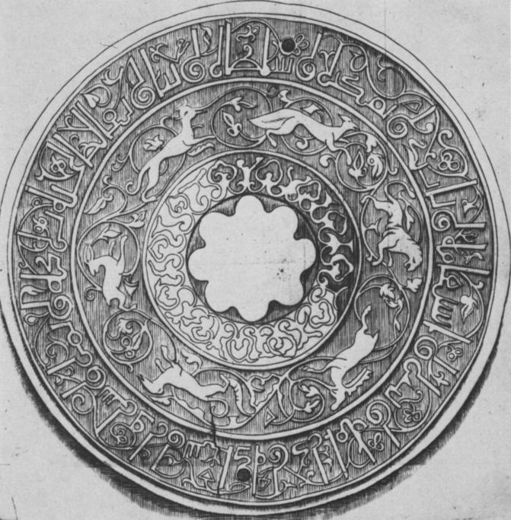

Fig. 48 Mirror showing animals and a inscription,  
ith—i 3th c. A. D. Found at Samarova,  
*Messerschmidt collection*

|  |  |  |
| --- | --- | --- |
|  | | Fig. 49  Mirror showing deities, copy (t zth--i 4th c.)  of a mirror of the 3rd  c. A.D. Found at Ust-Yes., *Minusinsk, Museum* |
| Fig. 5o  Mirror with ribbon-like  ornament, tith—rzth c.(?). Diam. 7,z cm. Found north of Minusinsk,  *National Eremitage, Leningrad* |  | |

Kirghiz. In their private life they not only used whole mirrors but also broken pieces. This is proven by the holes and the smoothed-down edges of many of the fragments. They also were covered with additional writing such as those on five mirrors, known to us, with scratched-in inscriptions in runic script. Moreover mirrors are repeatedly mentioned in local written sour­ces.46

Consequently, the imported mirrors were not numerous enough to meet the demand, and local copies were made on a large scale within the Kirghis state. The necessary raw material and the highly developed crafts were available in the Minusinsk Basin. From the large number of different Chinese types the Kirghiz chose only a few for copying. To these belong first of all, probably on account of their decorative motifs which were congenial to the Kirghiz, those with representaions of animals and grapevines, and those with four running animals. One can cer­tainly say that the wide diffusion of mirrors among the local population played an important role in the penetration of elements of T'ang ornament into the art of the Kirghiz.

Borrowing Sasanian, T'ang and Middle Eastern motifs, the Kirghiz artisans quickly worked out their own style, the best examples of which are found in the famous finds in the Cha-tas near Kopen.47

Characteristic for this time is the existence of a clearly marked difference between the im­ported and the locally cast pieces. The imported mirrors show the white metal typical of T'ang times, and carefully executed ornaments with precisely worked out details. As a rule they are massive. The locally made mirrors usually have effaced or washed out looking ornaments and often barely distinguishable details. The metal of the local products is yellow and usually covered with a dark patina. This difference in the metal is confirmed by spectral analysis which furnishes clear criteria for the separation of these two large groups. The analysis in turn makes it possible to divide these groups into smaller subgroups with a specific metal composition. Thus, for instance, mirrors with a decor representing animals and grapevines differ from the rest of T'ang mirrors in their metal composition.

The next period comprises about three hundred years. It begins with the time of the esta­blishment of the rule of the Khitan in Mongolia (92o A. D.), and ends with the time when the Kirghiz khakans join the Mongol empire (beginning of the thirteenth century). Into this period may be placed a large group of mirrors, about 7o pieces, not counting the copies of Han mir­rors which will be dealt with separately. According to traditional notions, the history of mir­rors ends with the T'ang period. The mirrors of later times have been considered coarse pro­ducts of little artistic value, and usually did not attract the attention of the scholars. Therefore the later mirrors have not been well studied, and it is often difficult to determine their date or to elcucidate their symbolism. The most important innovation introduced in the period under review is the wide diffusion of mirrors with a lateral handle. At present it is very difficult to say whether this innovation had anything to do with some outside influence. The Japanese scholar 0. Suzuki claims that their origin must be sought in the mirrors of the Siberian Shamans of the Scythic or Sarmatian periods.48 It is also quite probable that the appearance of mirrors with a handle was a natural result of the decline of the ancient beliefs. The mirrors cease to express the

**46** See S. E. Malov, *Yeniseiskaya pismennost tyurkov,* Moscow-Leningrad, 1952, p. 5o.

**47** L. Yevtyukhova, S. Kiselev, "Caa-tas u sela Kopeny", *Trudy Gosudarstvennogo Istoriceskogo muzeya,* Moscow, no. VI, 194o.

48 Suzuki 0., "A concave mirror of Koryo dynasty and its earlier phases", *Chosen gakubd,* no. 54, Tenri University, 5959.

ancient cosmogonic ideas and become utilitarian objects decorated with new auspicious symbols. On the earlier mirrors with handles we find as a survival the central knob button. As examples may be cited a few mirrors where the knob on the back is either the centre of a eight-petalled floral rosette, or is placed completely without justification in the middle of a landscape which covers the back (fig. 4o).

A characteristic mark of this period is the use of inscriptions scratched into the edges. The wide diffusion of scratched inscriptions on mirrors of the tenth-thirteenth centuries is connected with the fact that as a result of a shortage of bronze the production of mirrors was reduced. Special officials regulated the quantity of mirror production and their sale.

The inscriptions on the rim served so to speak as a stamp authorizing the sale of the mirror. Five such mirrors with inscription-stamps on the rim are in our collection.

The widely diffused tendency of the T'ang period to decorate mirrors with floral ornaments continued during the Northern Sung (tenth-twelfth centuries).49 The thick mirrors of T'ang times excuted in high relief change in Sung times into thin mirrors with narrow borders. Their ornamentation is, as a rule, smaller and more detailed and usually executed in thin lines in not very high, even relief. A magnificent example of these mirrors is one with a lotus around the central knob and repeated stylized flowers along the edge (fig. 28). This mirror is very beautiful and decorative. However, compared to T'ang mirrors it lacks strength and unity, and the orna­ment is too complex.

Another type with floral ornamentation was also widely diffused in the Minusinsk Basin, where five such pieces were found. Here the ornament conserves the symbolism of the wedding mirrors of T'ang in vestigial form: In the inner zone a pair of phoenixes is placed among stylized clouds, and along the edge we see stylized tendrils of the grapevine.

Three mirrors with identical ornamentation give a new type of decor, not known in T'ang times. The decorated area is occupied by a landscape with luxuriant trees and flying birds.

An important group of mirrors is embellished with traditional zoomorphic motives, mainly phoenixes and dragons. Here belong two examples of wedding mirrors with the representation of two phoenixes with lowered wings and long necks among cloud scrolls, and also mirrors with a peacock in the centre and birds (geese, orioles, mandarin ducks) around the edge.

A design as traditional as the dragon is very frequently found in stylized form on mirrors of this time being represented here by 9 pieces. Some of these were probably produced locally. Judging by analogy, one can say that this type of mirror was widely diffused in Sung times. A second type represents two dragons with snake-like winding bodies. This type is not found in the catalogues available to us (fig. 29).

Of the symbols of good omen found, two fish were very widely diffused in this time as sym­bols of numerous offspring.50 We have in our collection seven examples of this kind of mirror, belonging to three different variants (fig. 3o). In the category of auspicious symbols for nu­merous male offspring belongs a mirror with the representation of four boys among flowers. These representations came from India in T'ang times, and by taking on a new symbolic mean­ing, became widely diffused in folk art (fig. 31).51

**49** Liang Shang-ch'un, op. cit., vol. 4, pp. z b-6 a.

**5°** See Shen Tsung-wen, *Lung feng i-thu tt* icsx,614-4, Peking, 1960, P13.74-79.

51 Gyllensvard, *op. cit.,* pp. 136-137.

To the innovations belong also the representations of coins in the centre of the mirror (the so called *Chuang-ching* mirrors). This device enjoyed wide diffusion in Sung and in Ch'ing times. In our collection we have one example of such a mirror with a Jurchen coin *tatin t'un pao* (i. e. Ta Chin t'ung pao) (II6I--II8I A.D.) in the centre.

In this period the tendency to decorate mirrors with scenes of religious, mythological, or auspicious meaning becomes stronger. This phenomenon is closely connected with the general development of art in pre-Mongol times. The repertoire of mirror decor is unusually large, and in many cases it is not possible to elucidate the symbolism.

The ornament of a large number of mirrors is as before related to Taoism. Into this cate­gory belongs above all a mirror with the representation of Wu-huang, a goddess, the Great Bear deity, living in the Polestar especially venerated by the Taoists. Beside her we see a servant and also a crane and a tortoise, symbols of longevity (fig. 32). The leading specialist on mirrors Liang Shang-ch'un classifies such mirrors as from Liao.52

Among the subjects which have been elucidated, we can mention mirrors illustrating the legends of Hsu Yu (fig. 33) and of Wang Chih (fig. 35). Three others probably represent the legend of the White Snake (fig. 34).

A strong influence of classical painting can be felt in the decor of some mirrors. An example are mirrors that show a woman playing with a dog and a small child. The decor of this mirror recalls the well known woman with a small dog in a painting by Chou Fang.

Outstanding in the group under review is a Chin "Tartar" mirror with a decor consisting of four animals and grapevines. The composition recalls mirrors of early T'ang. On the rim is an inscription indicating that the piece was made in the third year of the Ch'eng-an era (1198). This is the only mirror in our collection bearing the exact date of manufacture (fig. 36).

Among the mirrors of the group five that bear a record of the place of their manufacture can clearly be set apart. Among these one with an ornament consisting of stylized floral motifs is of the greatest interest. On the left side we find two rows of characters in a frame (fig. 37). Un­usual is a type of mirror with a border of stylized flowers and an effaced inscription on the other side.

Two mirrors show the typical signs of Southern Sung mirrors, made in Hu-chou, which was the most important centre of mirror production. They are without ornament, thin and have a raised border along the edge. The only embellishment of the mirror is the inscription placed in a frame (fig. 3 8).53

Of great interest are the finds of some Korean and Japanese mirrors in the Minusinsk Basin. To the Korean group belongs probably a mirror with the picture of a landscape, and fish and crabs (fig. 39). A magnificent example of a Japanese mirror of the twelfth century has a repre­sentation of a landscape with fanciful rocks and cranes and geese. Probably into the pre-Mongol period also should be dated an enigmatic mirror with an ornament of arches (fig. 4!). An im­portant part of the mirrors of the pre-Mongol period comes from the Khitan state of Liao (middle of the tenth—beginning of the twelfth c.). From this period date about half of this

52 Liang Shang-ch'un, vo1.4, p.28.

53 Concerning mirrors from Hsu-chou see Wang Shih-lun, "T'an-t'an Hu-chou ching" ± ri A g itg a, rren‑

*wu,* 1958, no.6.

group. These works are evidence of the technological, cultural, and economic connections be­tween the principalities of the Kirghiz and the Kingdom of the Khitan.

After the destruction of the Kirghiz, the Khitan moved farther into Mongolia, fortifying their northwestern border by the construction of a line of strongholds. Being direct neighbours of the Khitan, the Kirghiz exchanged embassies 54 with them several times, and the Kirghiz nobility went to Liao" to obtain an education. These connections persisted even after the down­fall of the Liao and the formation by Khitan refugees of the state of Kara-Khitai.56

The appearance of Korean and Japanese mirrors in the Minusinsk Basin falls into Khitan times. This curious phenomenon is due to the numerous political and commercial relations of the Liao empire with these two countries.57 As a result of these relations Japanese and Korean wares could be carried without difficulties into the far away corners of the Khitan empire. Furthermore, according to reports in the dynastic history of the Khitan *Liao-shih* the most im­portant northwestern fortress Ko-tun, with a garrison of 20,000 men, was founded on the river Kerulan in 1004 A.D., and after that a large number of Bokkaits and Jurchen from the Korean frontier 58 were sent there. Their immigration also introduced Korean and Japanese goods near the border of the Kirghiz principalities, and from there these wares, especially mirrors, could easily find their way into the Minusinsk Basin.

The large number of mirrors datable to Chin times, proves that in the foreign relations of the Kirghiz the Jurchen took over the place of the Khitan. But we can also say that the rule of the Jurchen did not extend as far West as that of the Khitan, and that we have little evidence of any kind of relations between the Kirghiz and the Chin.

Between the Kirghiz and the Sung Empires lay first the Liao kingdom, and then that of Chin. In spite of that Sung mirrors continued to reach the Minusinsk Basin. In that the Khitan and the Chin were the intermediaries.

The difference between the imported mirrors and the local copies is less marked in this period than in the previous ones. In T'ang times when the border ran very clearly along the periphery, T'ang and local mirrors differed slightly as well in the composition and quality of the metal as in the character of their ornament.

In the wake of the rise of the states of the Liao, Hsi Hsia, and later the Chin on the territory of North China, a sharp distinction between main centres and local centers of production no longer can be seen.

To this we have to add, that everywhere the quality of the metal declined, and the ornament degenerated.

The last group includes mirrors of the Mongol rule in the Minusinsk Basin, and the follow­ing times (beginning of the thirteenth to sixteenth centuries). The large quantity of mirrors falling into this group (more than ioo pieces, not counting the copies of Han types) indicates that mirrors continued to be widely used among the local population. The decline of this ancient

**54** K.W.Wittfogel and Feng Chia-sheng, *History of Chinese Society, Liao* (9o7-1125), Philadelphia, 1949, pp.103-104, 320.

**55** N.V.Kyuner, "Novye Kitaiskie materialy po etnografii Kyrgyzov (Khakasov), 7-8th c. A. D."; *Zapiski khakasskogo naucnoissledovatslskogo instituta yazyka,* literatury i istorii, no.II, Abakan, 1951, p.Iz.

56 V.V. Barthold, *Kirghizy,* Frunze, 1943, pP.43-44.

**57** Wittfogel and Feng, *op. cit.,* pp.149, 180, 318, 347.

**58** *Ibid.,* p.67.

art which had begun in the previous period continues. The mirrors of this time contain nothing really new, neither in form nor in their ornaments.

Because the late mirrors have been so little studied it is very difficult to make a clear dis­tinction between Chin and Yuan products. Furthermore it should be noted that in the thir­teenth century the Mongols continued to use mirrors of the Sung and Chin types.

The mirrors belonging into this final group can be divided into five groups: with floral ornamentation, auspicious symbols, genre (scenes), decorated exclusively with inscriptions, and mirrors of Near Eastern origin.

The mirrors with floral ornaments clearly show the degeneration of this type. The majority are of poor quality and, as a rule, are local productions. The most popular were mirrors with a spiral-like floral ornament, of which were found eleven pieces (fig. 42).

We must also mention mirrors with a representation of six stylized flowers. This type was widely diffused on the territory of the vast Mongol empire, as is proven by finds of analogous mirrors on the territory of the Golden Horde, now in the Historical Museum in Moscow.

Three mirrors are decorated with a stylized lotus, the ancient Buddhist symbol. One with representations of floral springs and clouds is already related to the post-Mongolian period.

Among the mirrors of the second group we have to mention first mirrors with representa­tions of a dragon, the ancient symbol which we know from the previous groups (fig. 43).

The mirrors which we are reviewing now contain several variants of this motif. On all of them the dragons are snake-like, without paws or wings. On one of the mirrors the dragons are strongly stylized, and look stump-like. In the left corner is an inscription. Of great interest in­deed is a bell-shaped mirror with a handle, of which four examples were found. The decorated area shows in relief the fish-dragon, a harbinger of good luck, among waves and clouds.

Among the other mirrors of this type is worth mentioning a mirror with the representation of twelve animals symbolizing the signs of the zodiac. Outstanding is a mirror showing a stylized lotus, in the petals of which are placed the so called "eight signs of good luck" (fig. 44). The decor of this mirror is closely connected with Buddhist symbolism.

Two mirrors date from Ming times. The decor, consisting of children with toys, birds, building and various figures, is imbued with auspicious symbolism.

Among the mirrors with genre scenes we must mention first a large group of mirrors, count­ing rz pieces. The decoration of these shows a boy with a donkey and three other persons at the bank of a river, and a tree in the background (fig. 45). We do not know what the symbolism of this picture is. It is probable that it is an illustration of some legend. The quality of these mirrors varies; some have well executed ornaments, but there are also bad copies.

On another, still larger group, counting 16 pieces, we see a standing man, behind him a servant with an umbrella, in front of him a tortoise, and a flying stork (fig. 46). W. Trousdale, publishing an analogous mirror, dated it in the twelfth century and related its diffusion in Cen­tral Asia to the expansion of the Kara-Khitan.59 The symbolism of the representation was not known to Trousdale. In our opinion this mirror must be dated in the Mongol period, and the centre of its manufacture should be placed in the Minusinsk Basin, where the largest number of them were found. The representation on the mirror shows the highest deity of Taoism, the

59 W. Trousdale, "A Chinese handle-bearing mirror from Northern Afghanistan", *Artibus Asiae, vol.XXIV,* 1, 1961.

ruler of the Stars, whom we know already from a mirror of Khitan times. Numerous mediaeval amulets with representations of that deity are known, and show the same composition.60

We must also mention a mirror with the representation of a rider galloping on a landscape background.

The remaining four mirrors of this category date from a much later period, that is from Ming. Here belongs a mirror with a knob-loop looking like a leg with the representation of a hermit on a landscape background, a typical mark of post-Mongolian mirrors, a bad copy showing two human figures in a landscape, and a mirror with a representation recalling a popular print. Against a garden background we see a woman in front of a mirror, with four children play­ing. In the centre is the artisans' mark, "made by Yuan". Furthermore, we should mention a mirror with a representation of a Taoist deity with two servants flying on a cloud, and a mirror with a Taoist hermit, a stork, a deer, and the mushroom *chi,* widely diffused symbols of lon­gevity.

The presence of a large quantity of mirrors (16 pieces) decorated with inscriptions only, constitutes a special characteristic of that first period. The largest group of these (6 pieces) bears the inscription: "Long life, wealth, and distinction", a traditional auspicious formula, used on mirrors beginning with Han times. The mirrors show three different variants in the writing of this formula. Judging by the clumsiness of the writing most are local products.

Close to these is a mirror with an inscription of four characters in frames. We must also mention here a mirror with an inscription attributed to Li Shih-min, the second emperor of the T'ang dynasty, and two mirrors with auspicious inscriptions.

A separate group constitute the Near Eastern mirrors. Two of these show sphinxes, the sacred animals of the Islamic Paradise, and have auspicious inscriptions on the rim. These ap­peared first probably in the twelfth century, and became widely diffused in numerous copies over the whole Islamic world in the Mongol period.61 By the trade routes they reached as far as Eastern Siberia, as is proven by the find of an analogous mirror in the area of Narym.62 Well known finds are also two mirrors, found in the Minusinsk Basin. One of these shows a rider (fig. 47), the other animals (fig. 48). Both are embellished with auspicious inscriptions and date from the twelfth—thirteenth century.63 Some of the mirrors in this group are also of local manufacture.

The study of the collection of pieces from the Mongol period shows an important expansion of the local manufacture of mirrors. This phenomenon must be related to the great displace­ment of populations under the Mongols and especially of artisans. As a result of these changes new centres of the manufacture of mirrors appear in the empire of the Mongols : the Minusinsk Basin, the Golden Horde, the towns of Middle Asia. The most important of these centres was the Minusinsk Basin, which had already a tradition of producing mirrors. Furthermore, the

60 See V. M.Alekseyev, *Opisanie Kitaiskikh monetovidnykh amuletov i blagozelatelnykh medalei* iz *kollekcii imperatorskogo Eremi­laza,* St. Petersburg, 1932, pp. 130-131

61 M. Reinaud, *Description des monuments musulmans du cabinet de M.le Duc de Matas,* Paris, 1828, Vol. 2, pp. 394-396. Also V. A. Krackovskaya, 0 *bronzovykb zerkalakh Donskogo muzeya.* Issledovania po istorii kultury narodov Vostoka, Moscow-Leningrad, 196o, pp. 356-36o.

62 Preserved in the University Museum, Tomsk, no.62o1.

63 D. V. Ainalov, P. F. Katanov, *Opisanie metalliceskogo zerkala s arabskoi nadpistu, prinadlezascego publicnomy muzeyu goroda Minussinska Yeniseiskoi gubernii, i neskolko slov o metalliceskikh zerkalakb, opisannykb drugimi,* Kazan, 1900.



In the Sung and Chin periods (eleventh—thirteenth c.) should be dated mirrors with in­scriptions which had been widespread in the second and first centuries B.C. The main ornament of these mirrors are the inscriptions, executed in the *chuan* style. On one mirror the inscription has been partly effaced, and on the obliterated spot are scratched-in characters, which probably served as a stamp, permitting the sale. Only the first two characters can still be deciphered, which can be translated: "to the North from the capital".

Widely diffused in Mongol times were also copies of mirrors of later Han with the represen­tation of Hsi Wang Mu. This is borne out by finds ranging from China to the territory of the Golden Horde. Related to this type is an interesting copy of a mirror of the end of the Han period with a representation of Hsi Wang Mu and Tung Wang Kung with their retinues and dragons. On the edge of the mirror is a lengthy inscription imbued with Taoist symbolism, mentioning Hsi Wang Mu, Tung Wang Kung, and the Taoist saints Tzu kao and Chi Sun-tzu (fig. 49).

Characteristic for the Yuan period are copies of early Han mirrors with four rosettes, and characters placed between them; similar inscriptions are found on the mirrors with heraldic birds.

Copies of mirrors of Western Han with an ornament of arches, which are widely diffused in the Minusinsk Basin, date probably from the Mongol period. As a result of the many castings the ornaments and the inscriptions on many pieces are hardly distinguishable.

A well preserved example of a mirror of the *ts'ao-yeh* type has to be dated into Chin or Mongol times (twelfth-fourteenth centuries).

Within the total number of mirrors of the ninth to sixteenth centuries in the collection the copies of Han mirrors numbering 7o pieces, make up about one quarter. The custom of copying Han mirrors goes back to the end of the T'ang period.65 In the following times, the manufacture of copies was practised on a large scale, a clear example of which is our collection. This was due to a number of reasons, such as archaizing tendencies in the ornamental arts, heightened interest in antiquity, the use of Han mirrors as amulets etc.

Since they are late copies these mirrors have less art historical significance as compared to the mirrors of the other groups, and for the study of Han mirrors they can only be used as supplementary material.

One striking fact brought out by the classification of these mirrors we have mentioned already above, namely that we can single out a few groups which enjoyed an especially wide diffusion, and were probably of local manufacture. Thus, the three main groups comprise 39 mirrors, that is considerably more than half of the total number of copies of Han mirrors.

While the group differs considerably from original Han mirrors in metal composition, it is however not uniform. This can be explained by the fact that they were made over a long period of time in many centres. As we have already pointed out above, an important sign differentiating these mirrors is the cutting off of the central knob-loop.

Thus, the collection of imported mirrors of the Minusinsk, known to us, numbers 346 pieces, and is divided in five groups, related to the fundamental phases in the history of the Basin:

65 Liang Shang-ch'un, op. cit., vol.3, pp.6b-7a. Also *Shen-bri ch'u-t'u tung thing* ffi ± $14 0,, Peking, 1959, nos.

96-99.

i. Mirrors of the Tagar period-4 pieces

z. Mirrors of the Tagtyk period— i z pieces

1. Period of the Turkish Khan-ships and of the Kirghiz supremacy-83 pieces
2. Pre-Mongol period-68 pieces.
3. Mongol, and Post-Mongol period-112 pieces.
4. Separate group of 9th—i6th c. copies of Han mirrors-68 pieces.

Looking up the places of finds of mirrors on a map, it becomes clear that the greatest number of mirrors were found to the south of the city of Minusinsk, as a rule, near Russian settlements during construction projects in the nineteenth century. Therefore these finds cannot give a true picture of the diffusion of the mirrors, since the larger part of the Basin remained untilled and unexplored. One fundamental deduction which can be made from the mapping of finds is that towards the Mongol period the area of the mirrors expanded considerably to the north, and mirrors of the twelfth—sixteenth centuries have been found in the area of Krasno­yarsk and Aeinsk.